SmartPOD Architecture

Why Use Clean Architecture
A modern, clean architecture template for .NET applications following domain-driven design principles and best practices. This template provides a solid foundation for building scalable, maintainable, and testable applications.

Architecture Overview

Core

Contains Enterprise Business Rules
Domain Entities
Interfaces/Abstractions
Application Logic (Use Cases)
DTOs and Enums
NOTE: This layer should not depend on any other project. Other layers depend on Core

Infrastructure

Implements Infrastructure Concerns
Database Access (EF Core, Dapper)
File systems, external APIs
Repositories that implement interfaces from Core
NOTE: Depends on Core

Presentation
User Interface Layer
ASP.NET Core Web API or MVC project
Controllers
Input/Output Models
NOTE: Depends on Core and possibly Infrastructure (but can be decoupled via Dependency Injection).

Shared
Cross-cutting Concerns
Common utilities
Validation
Logging
Shared constants
NOTE: Accessible by all other layers without introducing tight coupling

Typical Implementation Flow
Example user registration:
- Presentation calls IUserService (defined in Core).
- Infrastructure provides UserRepository implementing IUserRepository.
- IUserService orchestrates domain logic.
- Entities and DTOs defined in Core.
- Results passed back to Presentation.

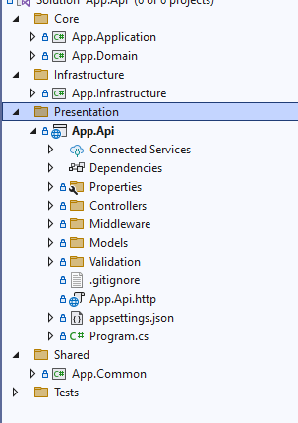

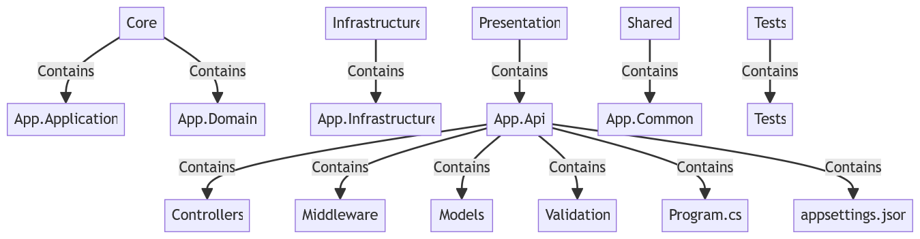

Project Structure

├── Core
│ ├── App.Application # Application logic, use cases, DTOs, interfaces
│ └── App.Domain # Domain entities, business rules, domain interfaces
│
├── Infrastructure
│ └── App.Infrastructure # Implementation of services, repositories, database access
│
├── Presentation
│ └── App.Api # ASP.NET Core Web API project
│ ├── Controllers # API endpoints
│ ├── Middleware # Custom middleware (e.g., error handling, logging)
│ ├── Models # Request/response models
│ ├── Validation # Validation logic (FluentValidation, etc.)
│ ├── Program.cs # Entry point
│ ├── appsettings.json
│
├── Shared
│ └── App.Common # Shared/common utilities, constants, helpers, extensions
│
└── Tests
└── Tests # Unit and integration test projec

Layer Details

App.Application

Purpose This is the Application Layer
Use Cases / Application Services
- Classes that orchestrate workflows (e.g., UserService)
- They coordinate repositories and domain entities to fulfill specific operations (like “RegisterUser” or “UpdateUserStatus”)
DTO
- Data Transfer Objects to move data in/out of the application layer
Interfaces
- Contracts for repositories and services (e.g., IUserRepository, IUserService)
NOTE:
Does Not:
- Contain infrastructure details (like Entity Framework)
- Contain persistence logic
Depends on:
- Domain Layer (because it uses Entities and Enums defined there)

App.Domain

Purpose This is the Application Layer
Entities
- Domain models (e.g., User, Order)
Value Objects
- Immutable types (e.g., Money, EmailAddress)
Enum
- Enumerations like UserStatus, UserRole
Domain Logic
- Business rules embedded in entities (e.g., validations, invariants)
NOTE:
Does Not:
- Know anything about infrastructure
- Depend on Application Layer or anything else
This is the purest layer of your system.

In Clean Architecture:
- Domain Layer (App.Domain): the innermost circle—pure business rules
- Application Layer (App.Application): use cases, which depend on Domain

App.Infrastructure

Purpose

This is the Infrastructure Layer
It contains all the technical details and implementation classes that connect your application to the outside world,
DBContext
This folder holds everything related to Entity Framework Core
File Name: ApplicationDbContext.cs
- Your EF Core DbContext.
- Defines DbSet<TEntity> properties to map entities to database tables.
- Configures model relationships.

File Name: IUnitOfWork.cs
- Concrete implementation of IUnitOfWork.
- Provides access to repositories and manages transaction scope.
File Name: UnitOfWork.cs
An interface defining a Unit of Work pattern, which:
- Groups multiple repository operations in a single transaction.
- Ensures all changes are committed atomically.

Repository
Implement data access pattern
File Name: BaseRepository.cs
- A generic repository with common CRUD methods.
- Typically operates on TEntity

File Name: UserRepository.cs
- Concrete implementation of IUserRepository interface (defined in Application layer).
- Contains User-specific queries and commands.

Service
File Name: UserService.cs
A technical service implementing IUserService (if you have it in Application layer).
Could contain business logic that requires infrastructure (e.g., sending emails, hashing passwords, background tasks).

NOTE:
Does Not:
- Contain infrastructure details (like Entity Framework)
- Contain persistence logic
Depends on:
- Domain Layer (because it uses Entities and Enums defined there)

App.Api

Purpose This is the Presentation Layer
This is your API layer—the part of the system responsible for
- Handling HTTP requests/responses
- Defining REST endpoints
- Configuring middleware
- Bootstrapping the application

Controller
Defines the endpoints for interacting with your system
File Name: BaseController.cs
- Typically an abstract base class all controllers inherit.
- Common features:
  - Access to the current user identity
  - Standardized response formatting
  - Error handling helper
File Name: UserController.cs
- Concrete controller exposing User-related API endpoints.
- Likely has methods such as:
  - GetUserById
  - CreateUser
  - UpdateUser

Middleware
Custom pipeline logic applied to all requests
File Name: Program.cs
- The application entry point.
- Configures:
  - Dependency Injection
  - Routing
  - Middleware
  - Application startup logic
File Name: appsettings.json / appsettings.Development.json
- Configuration files.
- Contain:
  - Connection strings
  - Logging settings
  - API keys
  - Other environment-specific settings
File Name: launchSettings.json
Defines how the API is launched locally (e.g., ports, profiles).

